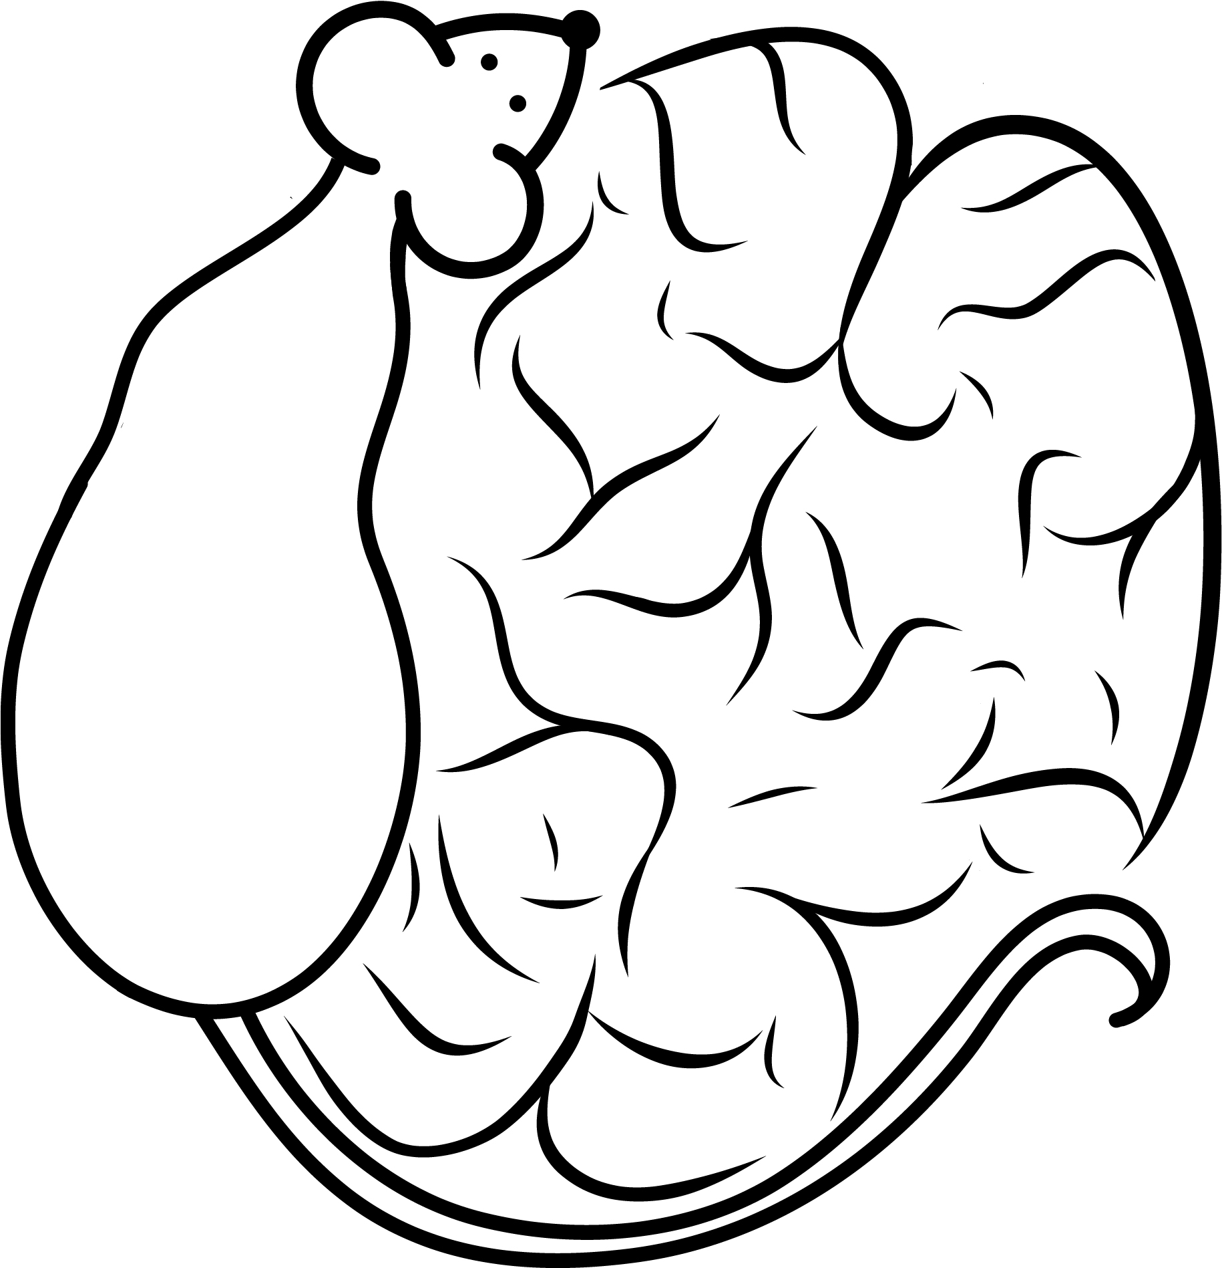

PSY320: Broadening Undergraduate Research Participation in Behavioral Neuroscience
  - Fall 2018
Instructor: | Matthew McMurray, PhD  Assistant Professor  Department of Psychology  Office: Psychology, Room 221  E-mail: matthew.mcmurray@miamioh.edu | Graduate Assistant: | Shannon Thompson  Graduate Student  Department of Psychology  Office: Psychology, Room 216  Email: thomp223@miamioh.edu

Class Meeting Location and Times
Times: MW 8:30-9:45am OR 4:00-5:15pm
Location: 242 Psychology Building
Note: Class sessions will also be held in the behavioral neuroscience laboratories (basement of Psychology Building) to facilitate laboratory training. On those days, notes will be posted on Canvas and announcements will be made in the preceding class.

Instructor Office Hours
Times: Wednesdays 2-4pm or by appointment
Location: Dr. McMurray’s office is located on the second floor of the Psychology Building, Room 221. He maintains an active research laboratory. Therefore, on occasion, his office hours will be held in the Behavioral Neuroscience laboratories (basement of Psychology Building). He will send an email and leave a note on his office door in that case.
Note: Dr. McMurray strongly encourages each of you to stop by early and often. Not only will this help you better develop your experiment, but it also lets him get to know you and get feedback on the course during the semester.

Graduate Assistant Office Hours
Times: Tuesdays 4pm-5pm, but preferably by appointment
Location: Shannon’s office is on the second floor of the Psychology building, Room 216 (across from Dr McMurray’s).
Note: Shannon should be your first contact point if you have questions or concerns. If she cannot satisfactorily answer your question, then please do not hesitate to come see Dr. McMurray during office hours (or by appointment).

Course Description
Please note: this class requires experimentation with live laboratory animals (rats) and preserved tissue.
The first half of the semester will focus on reading empirical articles related to your project and developing a team-based Undergraduate Research Award (URA) proposal. The remainder of the semester, we will prepare the Institutional Animal Care and Use (IACUC) protocol describing each experiment, and begin learning the necessary research skills that will be necessary for you to complete your project during the winter and spring terms. Finally, each team will present their experiment idea in poster format on Saturday, December 8th from 10am-1pm. This Saturday session is required, and the date/time is non-negotiable. Everyone must be there to present. This is the only session this semester when everyone will meet together. This is an important opportunity to receive feedback and provide feedback to other teams. Please mark your calendars now. In order to meet the rigorous expectations, you and your team members will be expected to meet outside of class to discuss articles, generate novel experiment ideas, and prepare your URA proposal and IACUC protocol segments.

Course Requirements
You are required to attend your assigned weekly discussion and lab sessions, complete all of the assigned work on time, and participate in group discussions outside of class.

Required Text
All required readings will be provided on Canvas, as well as suggested background readings. Additionally, students may find consultation of a textbook helpful, and are thus referred to the below, both of which are available at the library:
- Pinel, JP (2013) Biopsychology, 9th Edition. Upper Saddle River, NJ: Pearson Education, Inc.
  - This is an undergraduate level textbook and will provide a good overview for students that need a refresher on fundamental topics related to the course.
- Kandel, E; Schwartz, J; Jessell, T; Siegelbaum, S; Hudspeth, AJ (2012) Principles of Neural Science, 5th Edition. New York: McGraw-Hill, Health Professions Division.
  - This is a graduate level textbook that focuses on cellular and molecular neuroscience, and will serve as an excellent reference for these topics; however, it is very in depth and may be challenging for students without significant previous coursework in this field.

Evaluation
- Research Topic (5 pts): Each team will first develop a general research topic. The specific details of the project (methods, hypotheses, etc.) will be refined by an extensive review of the associated literature.
- Reading list (10 pts): Each team will develop a project reading list over the course of the semester, in consultation with Dr. McMurray and Shannon. This reading list will be continuously updated to include articles that have been read and discussed by your team, as well as articles to-be-read.
- Annotated Bibliography (10 pts): Each team will prepare an annotated bibliography of their reading list. Each annotation should be only 3 sentences (hypothesis, result, relevance to group project).
- Review of URA proposals (5pts): Each individual will review another group’s URA proposal. These reviews will be blind, and will be used to guide revisions.
- URA Proposal (20 pts): Each team will prepare a written proposal outlining the details of their experiment. This proposal should be highly detailed (similar to a published empirical paper). A full introduction with clear rationale for the experiment, detailed methods, expected results (with graphs), interpretations, limitations, and alternative approaches should be included.
- Animal (CITI) Training (5 pts): All students must successfully complete the online portion of the mandatory CITI training. Without successfully completing the animal training, you cannot continue in the BURP-BN program.
- Review of IACUC protocols (5pts): Each individual will review another group’s IACUC protocol draft. These reviews will be blind, and will be used to guide revisions.
- IACUC protocol (15 pts): Each team will prepare sections of the class IACUC protocol describing their proposed experiment. Before experiments can begin in winter/spring, they must be approved by the IACUC.
- Poster and presentation (15 pts): Each team will prepare a poster outlining their proposed experiment. Posters will include the following sections: background/rationale, methods, expected results, and interpretations. Poster presentations will take place on Saturday, December 8th, 10:00am-1:00pm. You will be given 15 minutes to present your poster. Additional time will be used to provide feedback.
- Attendance and Participation (10 pts): Attendance and participation at all discussion and lab sessions is mandatory.
Final Grade (100 pts): The scores of all score-able course materials will be summed to generate your final grade. You must earn a final course grade of B- or better to continue in the BURP-BN program. Final grades will be earned according to the following scale:
Total % Grade  100% A+  94 – 99% A  90 – 93% A- | Total % Grade  87 – 89% B+  84 – 86% B  80 – 83% B- | Total % Grade  77 – 79% C+  74 – 76% C  70 – 73% C- | Total % Grade  67 – 69% D+  64 – 66% D  60 – 63% D-  <59% F

Academic Dishonesty
Academic Integrity is at the heart of the mission and values of Miami University and is an expectation of all students. As the Code of Love and Honor states, “We stand for honesty, integrity, and the importance of moral conduct.” This is an expectation for all Miami community members. Maintaining academic integrity is a reflection of your character and a means of ensuring that you are achieving the outcomes of this course and that your grades accurately reflect your learning and understanding of the course material.
Both Miami University and the Psychology Department are dedicated to providing a learning environment based not only upon academic excellence, but academic integrity as well. In this course it is expected that you will adhere to all Miami University guidelines regarding academic misconduct. For more information about academic integrity, please review the Academic Integrity Information Guide and the Policy or Miami University’s Academic Integrity policy found in Part 1, Chapter 5 of the Student Handbook. Please review this policy, and note that lack of knowledge or understanding of the appropriate academic conduct is not an excuse for committing academic dishonesty. Students who are found responsible for committing academic dishonesty will receive a sanction that ranges from a zero on the assignment to an F in the course, which could also include the AD transcript notation. Students who commit academic dishonesty twice will automatically be suspended from Miami. If you have questions about how to complete an assignment or what could constitute academic dishonesty for a particular assignment, please feel free to visit Dr. McMurray during office hours. Dr. McMurray also encourages you to meet with him if you suspect that another student in the course has engaged in academic misconduct.

Attendance, Missed and Late Assignment Policies
To succeed in this class, you absolutely must attend all class meetings. There will be NO MAKE-UPS FOR IN-CLASS ASSIGNMENTS OR LABORATORY EXERCISES. If you miss the class for any reason, you will be assigned a zero for any missed assignments, as well as a reduction to your attendance score. Late assignments will not be accepted for any reason. If you know that your submission will be late, I encourage you to contact the instructor ahead of time to arrange for an extension if your circumstances warrant it.

Students with Disabilities
Miami University is committed to maintaining a barrier-free environment so that individuals with disabilities can fully access programs, courses, services, and activities. Students with disabilities who require accommodations for full access and participation in the course must be registered with Student Disability Services. Accommodations are available for students who have disabilities; however, accommodations can only be granted if requested through Student Disability Services (SDS). If you choose to disclose your disability to Dr. McMurray to receive accommodations, SDS will provide you with a letter to present to Dr. McMurray. This letter will confirm that you are registered with SDS and will list reasonable accommodations recommended by SDS. You should plan to meet with Dr. McMurray during office hours ASAP to discuss the accommodations and make sure a plan is in place. Please notify Dr. McMurray during the first week of class if you need any accommodation for the course, or immediately after a diagnosis has been made during the semester, so that the expectations for all parties are clear. It is YOUR responsibility to initiate this process.

Other Important Notes
- Dr. McMurray will make every effort to post materials on Canvas prior to each class meeting. However, he cannot guarantee they will be posted in time for you to access them ahead of time. Additionally, the instructors reserve the right to make changes to course materials at any time, including after the content has been discussed in class. This allows for materials to be updated based on the amount of material covered, and helps the instructors remember the topics you have struggled with, so they know how better to present them in future semesters.
- Cell phone use during class is prohibited. Students may be asked to leave if disruptions persist. Please put your phones into airplane mode before entering the classroom.
- Laboratory Safety is of paramount importance. Students who endanger themselves, their classmates, or their research subjects (the animals) may be asked to leave the classroom/laboratory at the discretion of the instructors. In this circumstance, the offending student(s) will receive a 0 for attendance for that day, and a 0 on any assignments they miss. Already completed assignments will be accepted. Behaviors that endanger others will not be tolerated, whether intentional or unintentional.
- Communicating professionally (via email or otherwise) is one of the most important skills to develop in modern society. The instructors expect you to use the same respect in email or online that you would in the classroom (e.g., addressing emails to Dr. McMurray or Professor McMurray, saying “please” and “thank you”, etc). We also expect that you will consult this syllabus and the Canvas site for announcements before emailing any instructors. Canvas will be used to make important announcements about the course. You should therefore check this important communication channel at least daily. If you decide to email an instructor, and your email is justified, we will do our best to respond quickly (usually by the end of the next business day); however, because our ability to answer complex questions via email isn’t perfect, don’t be alarmed if we suggest that you ask a question in class or in office hours. Additionally, we may suggest this if we get the same question from multiple students. Instructors will not respond to email received after 9pm until the following morning, and longer delays may occur on weekends.

Course Schedule (subject to change):
Week | Date | Topic | Assignment Due
1 | 8/27 | Program overview, group assembly, and contracts
 | 8/29 | Review of behavioral neuroscience (anatomy, etc.)
2 | 9/3 | No class (Labor Day)
 | 9/5 | Intro to animal models and experiment design | Research topic due 9/9, midnight
3 | 9/10 | Intro to literature searches, develop reading list | Reading List due 9/11, midnight
 | 9/12 | Implement and adjust reading list
4 | 9/17 | Overview of URA proposal and begin working on URA | Annotated Bib. due 9/17, midnight
 | 9/19 | Continue working on URA
5 | 9/24 | Continue working on URA
 | 9/26 | Continue working on URA
6 | 10/1 | Continue working on URA
 | 10/3 | Continue working on URA | URA drafts due 10/2, midnight
7 | 10/8 | Revise URA applications | Reviews due 10/7, midnight
 | 10/10 | Revise URA applications
8 | 10/15 | Introduction to animal use and tour of labs | URA due to ORU by 5pm
 | 10/17 | Overview of IACUC application and begin application | CITI training due 10/16, midnight
9 | 10/22 | Continue working on IACUC application
 | 10/24 | Continue working on IACUC application
10 | 10/29 | Continue working on IACUC application
 | 10/31 | Continue working on IACUC application
11 | 11/5 | Continue working on IACUC application
 | 11/7 | IACUC application Drafts Due
12 | 11/12 | Revise IACUC application | Reviews due 11/11, midnight
 | 11/14 | Revise IACUC application
13 | 11/19 | Finalize IACUC applications | IACUC application
 | 11/21 | No class (Thanksgiving)
14 | 11/26 | Discuss poster format and begin work on posters
 | 11/28 | Continue working on posters
15 | 12/3 | Continue working on posters
 | 12/5 | Continue working on posters | Posters due to printer (PSY Office)
 | 12/8 | Poster Presentations

